**SQL and Database 40**

*13:05 Video*

**What is a database?**

It is a structured set of data held in a computer, especially one that is accessible in various ways. It is a collection or gathering of information. It should be organised and manageable.

A database is a container for all your tables (and other SQL structures that relate to those tables). We must be able to structure tables to contain the right type of information, so that we can query it.

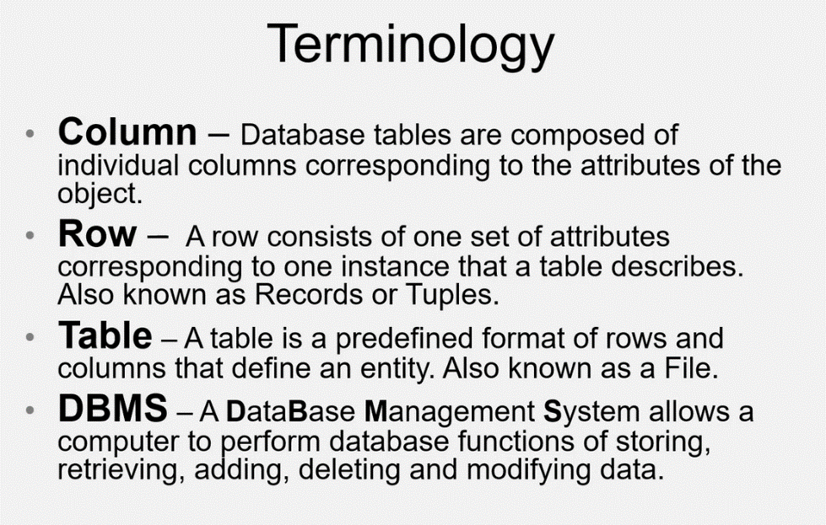

Examples of a DBMS:

* Oracle – not free to be used
* MySQL – a relational database, most widely used
* Microsoft Access – handles small amounts of data (simple)
* SQL Sever - runs on Microsoft Windows, is a relational database and is better for larger database
* MongoDB – used for big data, based on jsn

Field: A cell in the table

There is a relation between the tables, so you do not need to repeat the author information so many times.

Some recommendations for table names:

* Don’t capitalise the table names
* Don’t add spaces but underscores instead

Flat-file Database: None of the information is repeated

Relational Database: For example: if an employee is working on more than one task but they are all linked for example through the employee ID.

In relational database, we have:

One to one: sometimes you need to separate the data instead of putting it one table because an employee may be only interested in certain parts of the person’s data and the rest of the data is irrelevant for them.

One to many: for example: You have a customer and you have a list of purchases and the customer may purchase several things.

Many to many: for example, you have a customer and the list of products and a table shows the purchases of the products.

A composite key is special type of the primary key.

If you want two fields to be a primary key, then you would need a composite key.

It’s based on the relation of the primary key. It can be repeated several times in the table. For example, a customer may purchase several times so their customer ID number may be repeated serval times.

Benefits of using the foreign key:

* You can change the name of the job titles in the table above as an example
* When you search, you can filter it according to the foreign key
* The job title languages can change according to which country language you are using but the foreign key ID will stay the same
* Takes less space which means its much faster to search an integer instead of a text

**Designing a Database (ERD)**

1:35

18th June 2021

**SQL**

SQL can be broken down into 4 parts:

mysql is more common to use in web applications than sql server.